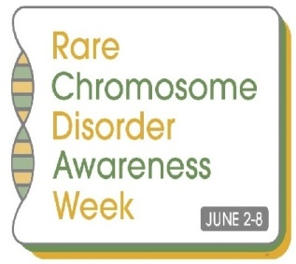

Events during awareness-raising week 2- 8 June 2014

This is a list of what our members and supporters are planning for the very first Rare Chromosome Disorder Awareness week: 2nd- 8th June 2014

If you’re also planning an event or have any questions, please feel free to add to this document or let us know via Unique’s Facebook Group
or on email to craig@rarechromo.org

Monday 2 June

- Joanna Dyckes (Sussex)– sponsored swim, see: www.justgiving.com/joanna-dyckes1
- Angela Eisele (USA) - has made shirts to sell, with all money collected to be donated to Unique. To buy a shirt, seewww.booster.com/brockeisele-fundraiser
- Caroline Hamilton (Jersey) – doing a balloon release
- Lorraine Murphy (Ireland) – taking part in the flora mini marathon in Dublin

Thursday 5 June

- Unique information and awareness stand at County Mall, Crawley, Sussex. Maz, Craig and Caroline from Unique will be there from 10am-3pm – please come and say hi!

Friday 6 June
- Steph Garbutt (Surrey) – Mufti day at daughter’s school, Cranmere Primary School in Esher
- Lynne Scott (Fife, Scotland) - Coffee morning with family and friends

Saturday 7 June

- Caroline Sutton (Yorkshire)- Disability Rocks - awareness stand for Unique.
- Jenny Edington (Middx) - opening her garden for Unique as part of the Ickenham festival
- Sharon Whyte/Samantha Bennett (Oxon)- Sat 7th & Sun 8th June: stall at a Carnival (Oxfordshire) to help reach the target of £3,500 so our friend can climb Mt Kilimanjaro for Unique and Breast Cancer Awareness! For more information or to get involved or donate, please visit our facebook page Not Just Travel / Whyte Sands and click on the David’s Charity Challenge tab.
- Sam Elliott (Hants)– Sponsored car wash at Paulton’s Golf Club (Jun 7th)
www.facebook.com/events/301391530028607/

Sunday 8 June
• Kerry Gray (Norfolk) - 15 mile walk

Monday 9 June

- Sarah Campbell (Yorkshire) – cake sale at local playgroup

Date to be confirmed

- Wendy Hunter – garden party
- Jane Turnbull (Australia)- daughters playgroup are holding a morning tea
- Jana Reschke and family are having a yard sale in Texas
- Samantha Williams (Bristol)– raising awareness & holding a collection at Mother-in-Law’s nursery in Bristol
- Kate Hirst (Yorkshire) – Little Acorns, Meltham Yorks – various fundraising
- Cathy Gallagher, Liverpool (and friends) – sponsored walk at Aintree racecourse
- Debbie Anderson in Guernsey, cake sale
- Sam Eldridge - cake sale
- Cath Smith (Derbys) - cake sale

Thanks to everyone for supporting Rare Chromosome Disorder Awareness Week!

Supporting anyone affected by rare chromosome disorders
and their families.

