Company no. 5460413
Charity no. 1110661


Rare Chromosome Disorder Support Group
Report and Financial Statements
31 March 2008

List of contents

Reference and Administration Details

Report of the Trustees
The Objects of the Charity and How These Are Achieved
Structure, Governance and Management

Objectives and Activities
Activities

Achievements and Performance

- Family Support Services
Magazine
Website www.rarechromo.org
Helpline
Conference
Maintaining the Unique Database
Family Matching Service
Information Project
Study days
Indirect Family Support delivered via Professionals
Trustees’ Summary

- Awareness Raising
Trustees’ Summary

Financial Review
Investments
Expenditure
Trustees’ Summary
Gifts in Kind
Reserves Policy

Plans for the Future

Statement of Responsibility of the Trustees

Independent Auditors’ Report

Statement of Financial Activities (Incorporating an Income and Expenditure Account)
Reference and Administration Details
Company Number |  |  | 5460413
Charity Number |  |  | 1110661
Registered Office |  |  | Valiant House
 |  |  | 3 Grange Mills Weir Road
 |  |  | London
 |  |  | SW12 0NE
Trustees |  |  | Trustees, who are also directors under company law, who served during the year and up to the date of this report were as follows:
 |  |  | Edna Knight |  | (Founder, Life President)
 |  |  | Eleanor Fiske |  | (Company Secretary)
 |  |  | Gillian Manvell |  | (Acting Chairman)
 |  |  | David Williams |  | (appointed 26 March 2008)
Principal Staff |  |  | Beverly Searle |  | Chief Executive Officer
 |  |  | Marion Mitchell |  | Family Support Officer
 |  |  | Prisca Middlemiss |  | Senior Information Officer
 |  |  | Sarah Wynn |  | Information Officer
 |  |  | Satnam Juttla |  | Information Officer
 |  |  | Julie Griffin |  | Finance & Fundraising Executive Officer
Chief Medical Advisor |  |  | Professor Maj Hulten
Bankers |  |  | Charities Aid Foundation |  | Birmingham Midshires
 |  |  | Kings Hill |  |  | PO Box 81
 |  |  | West Malling |  | Pendeford Business Park
 |  |  | Kent |  |  | Wobaston Road
 |  |  | ME19 4TA |  |  | Wolverhampton
 |  |  |  |  |  | WV9 5HZ
Auditors |  |  | Godfrey Wilson Ltd
 |  |  | Chartered Accountants & Registered Auditors
 |  |  | Pike House
 |  |  | George Street
 |  |  | Nailsworth
 |  |  | Gloucestershire
 |  |  | GL6 0AG

Back to contents

The Trustees present their annual report and accounts for the year ended 31 March 2008.

Reference and administrative information set out on page 1 forms part of this report. The financial statements comply with current statutory requirements, the memorandum and articles of association and the Statement of Recommended Practice – Accounting and Reporting by Charities (issued in March 2005).

The Objects of The Charity and How These Are Achieved

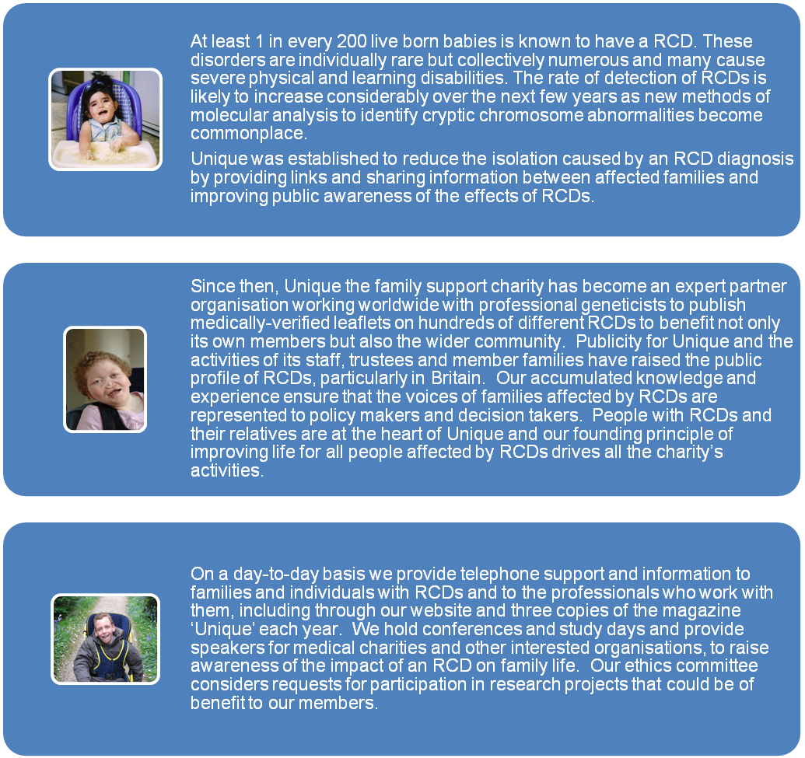

Back to contents

Structure, Governance and Management

The Rare Chromosome Disorder Support Charity, known as ‘Unique’, was founded by and is led by the families of children and young people with rare chromosome disorders (RCDs) for the benefit of all people with RCDs.
Unique’s History
Click here

The Rare Chromosome Disorder Support Charity, Unique, became a registered charity on 24 July 1993. The charity was incorporated on 24 May 2005 with company number 5460413. The company is registered as a charity with number 1110661. The company is limited by Guarantee; the amount guaranteed by each member is not in excess of £1.

The charity, as an incorporated company, is governed by its Memorandum and Articles of Association. Each of the Trustees is a director of the company and references to trustees include references to the same persons as directors.

Trustees are recruited by advertising openly in our members’ magazine, in appropriate media targeted at people interested in voluntary positions within the not-for-profit sector and through personal contacts. Following a self-assessment and skills audit in 2005, the Board seeks to recruit additional trustees, especially people with professional experience in the financial, HR and PR/marketing sectors and those who represent the views and experience of families from a diverse range of ethnic backgrounds.

Potential trustees are interviewed by one or more trustees and the CEO, who then make a recommendation to the Board. Prior to attending a trustees’ meeting, a new incumbent is provided with full documentation on the charity’s activities and plans and on his/her role and responsibilities as a Trustee and company director. A new trustee may contact other Board members for more information.

In March 2008 we welcomed David Williams as a new trustee. David has a background in financial services with particular strengths as a strategist.

The Board of trustees of the charity meets regularly with the CEO, the FFEO and staff as relevant, to define strategy and review performance. The Executive Committee meets to oversee implementation of strategy. The trustees delegate their responsibility for the day-to-day activities of the charity to the CEO, assisted by the FFEO in financial matters. To improve efficiency and facilitate expansion of services, an Operations Manager is to be employed from May 2008.

The major risks to which the charity could be exposed, as identified by the trustees and senior staff, have been recorded and kept under review since 2005 with contingency plans in place should operating conditions and/or performance change.

The trustees are listed on page 1 of the accounts. The trustees have no beneficial interest in the charitable company.

Members of the Executive Committee serving during the year were as follows:

Beverly Searle (Chief Executive Officer - CEO)
Meet the Staff
Click here

Meet the Committee
Click here

Julie Griffin (Finance & Fundraising Exec Officer - FFEO)

Prisca Middlemiss (Senior Information Officer)

Marion Mitchell (Family Support Officer)

Satnam Juttla (Information Officer) - Appointed 1 July 2007

Sarah Wynn (Information Officer) - Appointed 1 September 2007

Carey Hunt

Lydia Dickie

Marie Layng

Professor Maj Hulten (Chief Medical Adviser)

Back to contents

Objectives and Activities

During its productive association with Pilotlight, charity mentors, in 2005/06, Unique developed a four-year operating plan which clarified the charity’s vision and aims, set its strategic direction and defined the operational parameters. The key objectives of Unique remain:

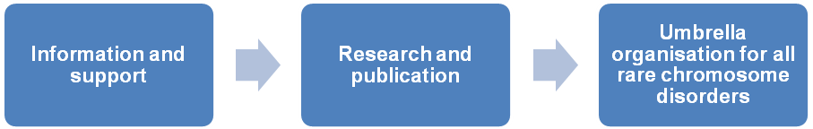

The strategy to achieve these objectives is to:

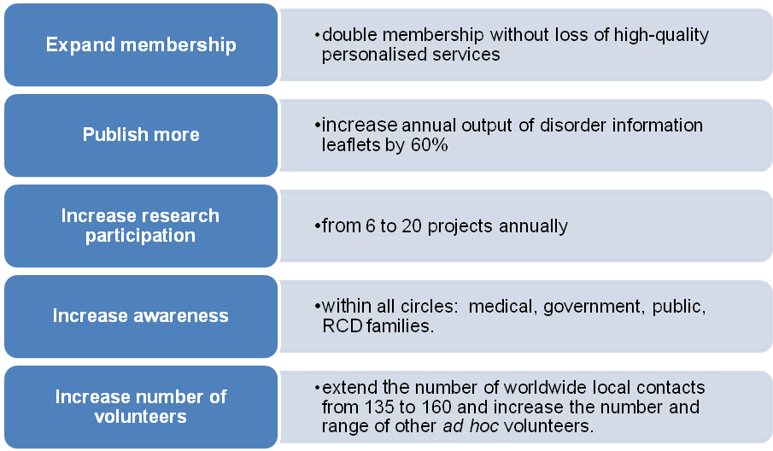

To effect and maintain the strategy demands increased financial and staff resources and strong partnerships with other organisations. During 2007/8, the activities of Unique’s staff and trustees were aimed at achieving stability while growing simultaneously the specialist services team to deliver more member families, better.

Back to contents

Activities

Unique’s core charitable activities are categorised under two primary headings:

- Family Support Services
- Awareness-raising.

- Family Support Services
Unique is an international support charity and aims to provide the following core services on an ongoing basis:

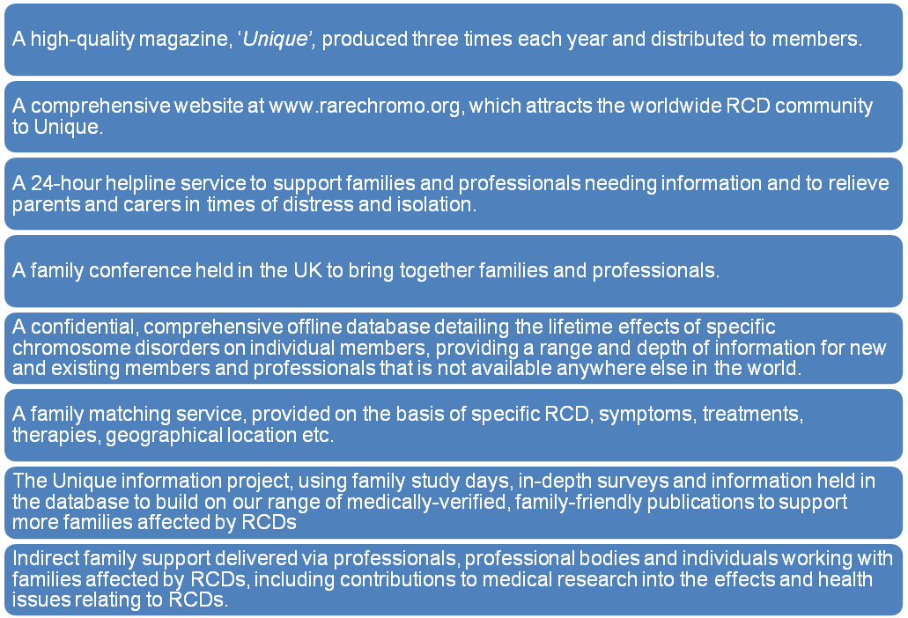

2. Awareness-raising

Unique aims to educate the general public about RCDs and generate funds through talks and presentations, using national and local media when appropriate. Unique also seeks opportunities to educate policy-makers about RCDs and their effects on family life.

Back to contents

Achievements and Performance

- Family Support Services

Membership of Unique continues to grow at a steady rate, illustrated by the following figures.

 | 31 March 2004 | 31 March 2005 | 31 March 2006 | 31 March 2007 | 31 March 2008
Member families (cumulative) | 4,000 | 4,500 | 4,920 | 5,350 | 5,800
New families | 488 | 412 | 400 | 430 | 450
Total countries (cumulative) | 64 | 65 | 68 | 69 | 73

While we have 5,800 member families, this actually represents well over 6,000 affected individuals with a RCD.

Back to contents

Magazine

We published our acclaimed magazine three times during the year, in which families and professionals shared their knowledge and experiences. To many families, the magazine is seen as the ‘face’ of Unique. The full-colour magazine is produced professionally to a high standard.

Members can “collect” an electronic version of the magazine from the new archive held in the password-protected part of our website. So far over 1400 member families have chosen the electronic delivery route, saving the charity a considerable sum in postage and printing costs and improving the charity’s carbon footprint.

Back to contents

Website: www.rarechromo.org

Our website continues to attract new members daily and interest from medical and other professionals world-wide. Since its launch, the website has received over half a million new visits.

In addition to the electronic magazine, members now have access to over 80 booklets covering hundreds of specific RCDs which are downloadable from the password-protected members’ area, with many more planned. Several leaflets are now available in other languages, providing much needed information for some of the isolated minority support charities in the UK as well as forging links with other European support charities.

Back to contents

Helpline
For more on what we do to help
Click here
The CEO, one of our part-time Information Officers and our Family Support Officer continue to man the 24-hour helpline and act as the initial point of contact for all new families. Positive feedback from members reinforces the value of the helpline. With two qualified geneticists on our staff, members are assured of reliable information about RCDs. Over 500 telephone enquiries and 20,000 email enquiries have been received in the year.

Back to contents

Conference

Our 12th conference is to be held near Daventry in October 2008. Grants totalling £12,000 received during the 2007/8 financial year have been allocated towards the cost of this event, to keep the registration fee as low as possible for families. Feedback from the last Unique conference in 2005 has informed our planning, ensuring that delegates will gain maximum benefit in 2008. We expect to welcome many new families and the quality of the weekend programme, the opportunities for learning, the wide range of workshops and the diversity of the accommodation on offer should ensure a most enjoyable event for all.
Click here
For 2005 Conference Report

Back to contents

Maintaining the Unique Database

Using the database, staff members are able to provide inquiring professionals with anonymised information about the effects of a specific RCD. This is particularly helpful when there is no Unique information booklet on a specific condition. Feedback from professionals, especially geneticists and paediatricians, has demonstrated that this service is invaluable to them in counselling and managing affected families.

All registered members were mailed at least once during the year with a copy of their database entry to approve, update and amend.

Back to contents

Family Matching Service

Newly diagnosed families in particular tell us that they value this service highly. It enables them to contact other member families, which in itself helps to relieve the feelings of isolation and stress felt by many member families. Lifetime friendships are created as a result.

Back to contents

Information Project
Click here
For Chromosome Disorder leaflets

Our team of Information Officers researches and produces our large, expanding range of family-friendly, medically verified leaflets. All of these are available to our members via our website. Thanks to our new information staff, we have also been able to review and update several of the earlier leaflets as well as producing new material for families.

This is another highly valued resource for families and professionals alike and medical professionals are able to access the entire range of publications either by paying a small licence fee or by agreeing to assist the Charity in some way.

Unique has also contributed to academic research and our Senior Information Officer, Prisca Middlemiss co-authored a peer-reviewed paper on ‘4q Deletion Syndrome – The Parents’ Perspective’ with Dr E.M Strehle.

Back to contents

Study Days

On September 30th 2007, in conjunction with a professional team from Oxford and Wessex, Unique held a study day in Oxford for UK families with a daughter aged between 2-16 with Triple X Syndrome. Feedback from the event was very positive and a report has been subsequently published and is available via the website. The trustees would like to expand our study day service in future, when appropriate levels of funding are available.
Click here
For XYY Study Day report

The response from families and professionals to the work of Unique is logged and reviewed continuously. Feedback arrives by letter, telephone, email and via the private members’ forum of the Unique website or through information submitted for publication in the charity’s magazine. The website www.rarechromo.org and magazine were redesigned in 2007 to encourage feedback from members of the public. The introductory pack sent to new inquirers contains a basic evaluation form and service guide sheets. More detailed evaluation forms are included with other appropriate correspondence and in conference and study day packs. The direction of future work is informed by feedback from members.

Back to contents

Indirect Family Support delivered via Professionals

Unique strives to raise awareness among a wide range professionals, as well as colleagues in other support charities, about the information and support the charity can offer when a family is newly diagnosed. This has been achieved in a number of ways, including:
For more on how we support Professionals
Click here
- Unique has continued giving presentations to numerous professionals and medical students over the past twelve months and has been invited to contribute as expert patient representative on a number of professional committees and working charities.
- Unique was invited to participate with an awareness-raising stand that attracted widespread attention at the British Society of Human Genetics Annual Conference, subsequently, three of the team were also invited to become members of BSHG.

Back to contents

Trustees’ summary

The trustees are exceptionally pleased with the prodigious output of disorder leaflets by the Family Support Services team, which families and professionals appreciate fully. The high quality, individualised responses to every family and professional continue to be highly prized. For this, we are very grateful to the commitment of the CEO, the three Information Officers and the Family Support Officer. We commend our CEO for setting high standards for Family Support Services, which has earned Unique a reputation amongst geneticists and other professionals of which we are justifiably proud.
Click here
To review Financial Expenditure associated with Family Support Services

Back to contents

2. Awareness Raising

Unique runs a UK and global network of 135 local contacts who distribute the charity’s awareness-raising posters and information leaflets to local hospitals, social work departments, doctors’ surgeries and special schools.

New members receive an introductory pack with awareness-raising literature to distribute in their local area.

Unique is promoted on innumerable public information databases and has established good working relationships with a wide range of organisations, including Contact a Family (CaF), the Genetic Interest Charity (GIG) and DECIPHER, a database of submicroscopic chromosomal imbalance All these organisations refer families and individuals affected by RCDs to Unique.

Unique has capitalised on several key events, such as the 2006 £100 000 RBS win, with concurrent publicity about RCDs. The impact of such coverage in national and local press has been noticeable.

Back to contents

Trustees’ summary

The trustees are pleased with the increased level of publicity Unique gained in the mainstream media. Although Unique is well known and highly regarded in professional circles, the trustees would like to raise the profile of RCDs and Unique more generally. During the year, opportunities for raising awareness among the general public have been used to maximum advantage and there have been major features in both paper and online versions of the Daily Mail newspaper.
Daily Mail article September 2007

Click here

Back to contents

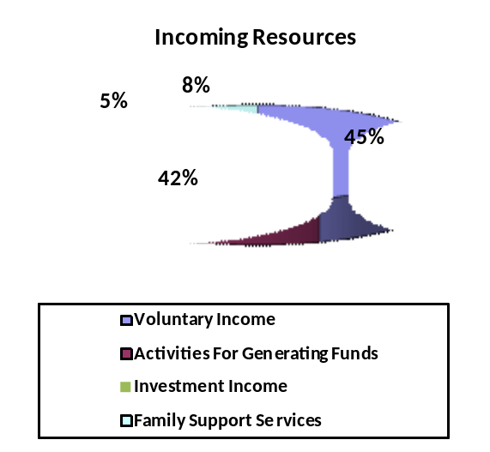Financial Review

Our primary source of unrestricted income is members, their friends, family and employers through donations, fundraising and matched-funding. We are extremely grateful to all those who made contributions – there was a significant increase in income from our members this year. However, we are mindful of the deteriorating economic climate and the potential impact this could have on our future income. We have tasked the executive team to explore hitherto unexplored sources of revenue in order to diversify our income sources for the forthcoming years.

Back to contents

Investments

A Tracey Emin print, “Little Family”, is owned by Unique with a reserve value of £700.

To maximise interest income from our reserves during the year, a Fixed Term Deposit was opened to invest £100,000 on a three month term. At maturity, the decision was taken to re-invest the full amount plus an additional £30,000 for a further three months.

Back to contents

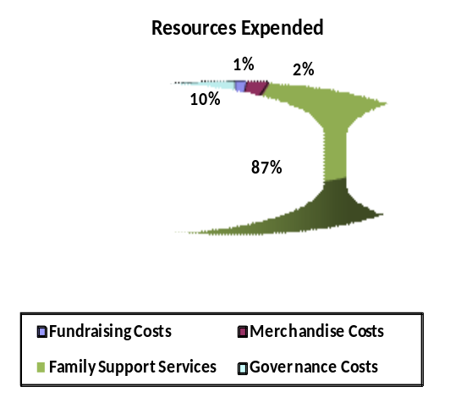Expenditure

Costs associated with the core family services are proportionate to the increase in membership, the increase in content of the magazine and related postage costs. Website and helpline running costs continue to be managed efficiently and are subsidised significantly by voluntary support. Resources used to support families via professionals are within budget. With the additional income from last year, we have been able to build on our services and provide more information and support to professionals serving the RCD community.

Back to contents

Trustees’ summary

The trustees would like to record their gratitude to the Finance & Fundraising EO for the compilation of monthly management accounts and her diligent approach to all tasks. Unique has been heavily reliant on this staff member but the recruitment of an Operations Manager in 2008/09 will complement and balance the responsibilities of the administration functions.

Back to contents

Gifts in Kind

With limited funding, Unique relies heavily on the generosity of individuals who contribute their professional expertise free of charge. The trustees wish to extend their sincere thanks to all these generous supporters and to mention particularly the following individuals:

- Trevor Searle, for his expertise and time spent on developing the Unique website and online capabilities. Without this free in-house resource, Unique would not have been able to develop and maintain its website and database.
- Patrick Griffin, for his expertise and time supporting the employees with their IT equipment requirements and software problems
- Professor Maj Hulten, who has spent countless hours checking and verifying Unique’s publications on specific disorders. Over the years, Maj has provided the professional geneticist’s view to the management committee.
- The many other expert medical professionals worldwide who have helped to verify and translate Unique’s publications.
- Carey Hunt, committee member, who provides her professional creative skills to design the excellent Unique publications.
- Special thanks to Sarah Trevitt for her work in organising our burgeoning number of enthusiastic marathon runners entering an every-increasing number of races. The trustees recognise Sarah for her time and commitment over the years and wish her well in the future.
- All local contacts, other group members, their families, friends and work colleagues who volunteer their time and energy selflessly to raise funds for the group.

Back to contents

Reserves Policy

The trustees aim to hold between 3 and 6 months of expenditure in reserves, which equated to £45,000 to £95,000 in general funds. At this level, the trustees felt that they would be able to honour previous commitments in the event of a significant drop in income. At 31 March 2008 unrestricted funds of £207,453 were held. This unusually high figure results from the receipt of £100,000 from the RBS Charitable Trust in 2006-7. However, with the increase in expenditure on core services planned for 2008-9, these funds are earmarked and so the financial situation at year-end is felt to be entirely appropriate.

Back to contents

Plans for the Future

The trustees’ immediate plans for the future include:
- Continuing to provide existing support for families affected by RCDs in order to relieve feelings of isolation and despair.
- Expanding services to meet the growing demand from both existing members and new members each year including hard to reach communities.
- Continuing to develop the core services and to increase income to permit an expansion of these services while reducing the current unreasonable burden on existing staff who work well beyond their paid hours to meet needs.
- Implementing the charity’s four-year operating plan to achieve these goals.

Key to the successful delivery and expansion of Unique’s core services is the number and quality of its staff. With the 2006 RBS win, funds became available to expand the capacity of both information project and the CEO’s frontline work with families and professionals. Grant applications were submitted for specialist support workers so that we could embark on an outreach project to find the ‘hidden’ families perhaps most in need of our services, simultaneously raising public and professional awareness throughout the UK. We wish to broaden what we can offer to our more mature young people. However our fundamental position is that there will be no expansion unless we can be sure of maintaining the high quality of personalised response to each and every member family. This is what Unique is known for and why the charity is valued so highly.

As trustees, it is our aim during the coming year to ensure the development of a sound infrastructure to underpin growth and assure continued quality. With one in 200 of the general population likely to be affected by some sort of rare chromosome disorder during their life, pressure on Unique’s services will be unremitting. It is our role to ensure that the charity can continue to welcome everybody faced with such a devastating diagnosis and provide the informed friendship that families will need for decades to come.
Read the Trustee Update

Click here

Back to contents

Statement of Responsibilities of the Trustees

The trustees are required to prepare financial statements for each financial year, which give a true and fair view of the state of affairs of the charitable company and of its incoming resources and application of resources, including the net income or expenditure, for the period. In preparing those financial statements the trustees are required to:

- select suitable accounting policies and then apply them consistently;

- make judgements and estimates that are reasonable and prudent;

- state whether applicable accounting standards and statements of recommended practice have been followed, subject to any material departures disclosed and explained in the financial statements; and

- prepare the financial statements on the going concern basis unless it is inappropriate to presume that the charity will continue in operation.

The trustees are responsible for keeping proper accounting records which disclose with reasonable accuracy at any time the financial position of charity and which enable them to ensure that the financial statements comply with the Charities Acts 1993 and 2006. The trustees are also responsible for safeguarding the assets of the charity and hence for taking reasonable steps for the prevention and detection of fraud and other irregularities.

The trustees confirm that to the best of their knowledge there is no information relevant to the audit of which the auditors are unaware. The trustees also confirm that they have taken all necessary steps to ensure that they themselves are aware of all relevant audit information and that this information has been communicated to the auditors.
Members of the charity guarantee to contribute an amount not exceeding £10 to the assets of the charity in the event of winding up. The total number of such guarantees at 31 March 2008 was 8. The trustees are members of the charity but this entitles them only to voting rights. The trustees have no beneficial interest in the charity.

Auditors

Godfrey Wilson Limited were appointed as the charity's auditors during the year and have expressed their willingness to continue in this capacity.

Approved by the trustees on 1 August 2008 and signed on their behalf by
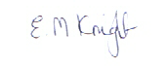
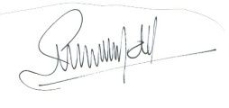

Edna Knight Gillian Manvell
Trustee director, Life President Trustee director, Acting Chairman

Back to contents

Independent Auditors’ Report

To the Members of Rare Chromosome Disorder Support Group

We have audited the financial statements of the Rare Chromosome Disorder Support Group for the period ended 31 March 2008 which comprise the statement of financial activities, balance sheet and related notes. These financial statements have been prepared in accordance with the accounting policies set out therein and the requirements of Statement of Recommended Practice: Accounting and Reporting by Charities (issued in March 2005).
This report is made solely to the charitable company's members, as a body, in accordance with section 235 of the Companies Act 1985. Our audit work has been undertaken so that we might state to the charitable company's members those matters we are required to state to them in an auditors' report and for no other purpose. To the fullest extent permitted by law, we do not accept or assume responsibility to anyone other than the charitable company and the charitable company's members, as a body, for our audit work, for this report, or for the opinions we have formed.
Respective Responsibilities of The Trustees and Auditors

The trustees (who are also directors of charitable company for the purposes of company law) are responsible for preparing the annual report and the financial statements in accordance with applicable law, United Kingdom Accounting Standards (United Kingdom Generally Accepted Accounting Practice) and the Statement of Recommended Practice: Accounting and Reporting by Charities (issued in March 2005). The responsibilities of the trustees are set out in the statement of responsibilities of the trustees.
Our responsibility is to audit the financial statements in accordance with relevant legal and regulatory requirements and International Standards on Auditing (UK and Ireland).
We report to you our opinion as to whether the financial statements give a true and fair view and are properly prepared in accordance with the Companies Act 1985. We report to you whether, in our opinion, the information given in the trustees' report is consistent with the financial statements. We also report to you if the charitable company has not kept proper accounting records, if we have not received all the information and explanations we require for our audit, or if information specified by law regarding the trustees' remuneration and other transactions is not disclosed.
We read other information contained in the annual report, and consider whether it is consistent with the audited financial statements. This other information comprises only the report of the trustees. We consider the implications for our report if we become aware of any apparent misstatements or material inconsistencies with the financial statements. Our responsibilities do not extend to any other information.
Basis of Opinion

We conducted our audit in accordance with International Standards on Auditing (UK and Ireland) issued by the Auditing Practices Board. An audit includes examination, on a test basis, of evidence relevant to the amounts and disclosures in the financial statements. It also includes an assessment of the significant estimates and judgements made by the trustees in the preparation of financial statements, and of whether the accounting policies are appropriate to the charitable company's circumstances, consistently applied and adequately disclosed.
We planned and performed our audit so as to obtain all the information and explanations which we considered necessary in order to provide us with sufficient evidence to give reasonable assurance that the financial statements are free from material misstatement, whether caused by fraud or other irregularity or error. In forming our opinion we also evaluated the overall adequacy of the presentation of information in the financial statements.
Opinion
In our opinion:
▪ | the financial statements give a true and fair view, in accordance with United Kingdom Generally Accepted Accounting Practice as modified by the Statement of Recommended Practice: Accounting and Reporting by Charities (issued in March 2005), of the charitable company's state of affairs as at 31 March 2008 and of its incoming resources and application of resources, including its income and expenditure, for the year then ended;
▪ | the financial statements have been properly prepared in accordance with the Companies Act 1985; and
▪ | the information given in the trustees' report is consistent with the financial statements.
 | 
27 August 2008
GODFREY WILSON LIMITED
Chartered Accountants &
Registered Auditors
Pike House
George Street
Nailsworth
Gloucestershire
GL6 0AG

Back to contents

Rare Chromosome Disorder Support Group
Statement of Financial Activities (Incorporating an Income and Expenditure Account)
For The Year Ended 31 March 2008
 |  |  |  |  |  |  |  |  |  |  |  |  |  |  |  |  | 2008 |  | 2007
 |  |  |  |  |  |  |  |  |  |  |  |  | Restricted |  | Unrestricted |  | Total |  | Total
 |  |  |  |  |  |  |  |  |  |  |  | Note | £ |  | £ |  | £ |  | £
Incoming Resources
Incoming Resources from Generated Funds:
 | Voluntary Income |  |  |  |  |  |  |  |  |  | 2 |  | - |  | 88,114 |  | 88,114 |  | 186,107
 | Activities For Generating Funds |  |  |  |  |  |  |  | 3 |  |  |  | - |  | 82,992 |  | 82,992 |  | 58,007
 | Investment Income |  |  |  |  |  |  |  |  |  |  |  | - |  | 10,643 |  | 10,643 |  | 5,118
Incoming Resources from Charitable Activities:
 | Family Support Services |  |  |  |  |  |  |  |  |  |  | 4 | 14,828 |  | 842 |  | 15,670 |  | 27,821
Total Incoming Resources |  |  |  |  |  |  |  |  |  |  |  |  | 14,828 |  | 182,591 |  | 197,419 |  | 277,053
Resources Expended
Costs of Generating Funds:
 | Fundraising Costs |  |  |  |  |  |  |  |  |  |  |  | - |  | 18,180 |  | 18,180 |  | 8,809
 | Merchandise Costs |  |  |  |  |  |  |  |  |  |  |  | - |  | 3,399 |  | 3,399 |  | 856
Charitable Activities:
 | Family Support Services |  |  |  |  |  |  |  |  |  |  |  | 16,921 |  | 141,513 |  | 158,434 |  | 132,882
Governance Costs |  |  |  |  |  |  |  |  |  |  |  |  | - |  | 17,479 |  | 17,479 |  | 9,987
Total Resources Expended |  |  |  |  |  |  |  |  | 5 |  |  |  | 16,921 |  | 180,571 |  | 197,492 |  | 152,534
Net Incoming Resources Before Gains & Transfers |  |  |  |  |  |  |  |  |  |  |  |  | (2,093) |  | 2,020 |  | (73) |  | 124,519
Gains on Investment Assets |  |  |  |  |  |  |  |  |  |  |  | 6 | - |  | - |  | - |  | 1,550
Net Movement in Funds |  |  |  |  |  |  |  |  |  |  |  |  | (2,093) |  | 2,020 |  | (73) |  | 126,069
Transfers of Funds from Charitable Trust |  |  |  |  |  |  |  |  |  |  |  |  | - |  | - |  | - |  | 86,303
Reconciliation of Funds
Total Funds Brought Forward |  |  |  |  |  |  |  |  |  |  |  |  | 6,939 |  | 205,433 |  | 212,372 |  | -
Total Funds Carried Forward |  |  |  |  |  |  |  |  |  |  |  |  | 4,846 |  | 207,453 |  | 212,299 |  | 212,372
All of the above results are derived from continuing activities. There were no other recognised gains or losses other than those stated above. Movements in funds are disclosed in Note 15 to the accounts.
 | Back to contents

Rare Chromosome Disorder Support Group
Balance Sheet
31 March 2008
 |  |  |  |  |  |  |  |  |  |  |  |  |  | 2008 |  | 2007
 |  |  |  |  |  |  |  |  |  | Note |  | £ |  | £ |  | £
Fixed Assets
Tangible Fixed Assets |  |  |  |  |  |  |  |  |  | 9 |  |  |  | 1,997 |  | 1,194
Investments |  |  |  |  |  |  |  |  |  | 10 |  |  |  | 700 |  | 700
 |  |  |  |  |  |  |  |  |  |  |  |  |  | 2,697 |  | 1,894
Current Assets
Stock |  |  |  |  |  |  |  |  |  | 11 |  | 1,453 |  |  |  | 1,203
Debtors |  |  |  |  |  |  |  |  |  | 12 |  | 6,693 |  |  |  | 12,731
Cash at Bank and in Hand |  |  |  |  |  |  |  |  |  |  |  | 205,962 |  |  |  | 201,054
 |  |  |  |  |  |  |  |  |  |  |  | 214,108 |  |  |  | 214,988
Creditors: Amounts Due Within 1 Year |  |  |  |  |  |  |  |  | 13 |  |  | 4,506 |  |  |  | 4,510
Net Current Assets |  |  |  |  |  |  |  |  |  |  |  |  |  | 209,602 |  | 210,478
Net Assets |  |  |  |  |  |  |  |  |  | 14 |  |  |  | 212,299 |  | 212,372
Funds |  |  |  |  |  |  |  |  |  | 15
Restricted Funds |  |  |  |  |  |  |  |  |  |  |  |  |  | 4,846 |  | 6,939
Unrestricted Funds:
 | General funds |  |  |  |  |  |  |  |  |  |  |  |  | 207,453 |  | 205,433
Total Funds |  |  |  |  |  |  |  |  |  |  |  |  |  | 212,299 |  | 212,372
Approved by the trustees on 1 August 2008 and signed on their behalf by
 |  |  |  |  |  |  |  |  |  |  | 
Edna Knight - trustee (Life President) |  |  |  |  |  |  |  | Gillian Manvell - trustee (Acting Chairman)

Back to contents

Rare Chromosome Disorder Support Group
Notes to The Financial Statements
For The Year Ended 31 March 2008
1. | Accounting Policies
a) | The financial statements have been prepared under the historical cost convention and in accordance with applicable accounting standards and the Companies Act 1985. They follow the recommendations in the Statement of Recommended Practice, Accounting and Reporting by Charities (issued in March 2005).
b) | Voluntary income is received by way of donations and gifts and is included in full in the statement of financial activities when receivable.
c) | Revenue grants are credited to the Statement of Financial Activities when received or receivable which ever is earlier, unless they relate to a specific future period, in which case they are deferred.
d) | Resources expended are recognised in the period in which they are incurred. Resources expended include attributable VAT which cannot be recovered.
e) | Depreciation is provided at rates calculated to write down the cost of each asset to its estimated residual value over its expected useful life. The depreciation rates in use are as follows:
 |  | Computer equipment |  |  |  |  |  | 4 years
 | Items of equipment are capitalised where the purchase price exceeds £500.
f) | Restricted funds are to be used for specific purposes as laid down by the donor. Expenditure which meets these criteria is charged to the fund.
g) | Unrestricted funds are donations and other incoming resources received or generated for the charitable purposes.
h) | Transactions in foreign currencies are translated at rates prevailing at the date of the transaction. Balances denominated in foreign currencies are translated at the rate of exchange prevailing at the year end.

Back to contents

2. | Voluntary Income
 |  |  |  |  |  |  |  |  |  |  | 2008 |  | 2007
 |  |  |  |  |  |  | Restricted | Unrestricted |  |  | Total |  | Total
 |  |  |  |  |  |  | £ |  | £ |  | £ |  | £
 | Royal Bank of Scotland Charitable Trust |  |  |  |  |  | - |  | 10,000 |  | 10,000 |  | 100,000
 | Health Foundation |  |  |  |  |  | - |  | 9,100 |  | 9,100 |  | 15,925
 | Waterloo Foundation |  |  |  |  |  | - |  | 5,000 |  | 5,000 |  | -
 | Creating Chances |  |  |  |  |  | - |  | 2,000 |  | 2,000 |  | -
 | Reuben Foundation |  |  |  |  |  | - |  | 100 |  | 100 |  | -
 | Bernard Sunley Foundation |  |  |  |  |  | - |  | - |  | - |  | 2,000
 | Share Gift |  |  |  |  |  | - |  | - |  | - |  | 1,000
 | Grants < £1,000 |  |  |  |  |  | - |  | - |  | - |  | 2,345
 | Donated Goods / Services * |  |  |  |  |  | - |  | 18,640 |  | 18,640 |  | 19,515
 | General Donations |  |  |  |  |  | - |  | 17,719 |  | 17,719 |  | 24,131
 | Corporate Donations |  |  |  |  |  | - |  | 11,368 |  | 11,368 |  | 5,748
 | Gift Aid |  |  |  |  |  | - |  | 10,325 |  | 10,325 |  | 8,230
 | Give As You Earn |  |  |  |  |  | - |  | 2,488 |  | 2,488 |  | 2,180
 | Overseas Donations |  |  |  |  |  | - |  | 839 |  | 839 |  | 3,105
 | Pyramids |  |  |  |  |  | - |  | 535 |  | 535 |  | 668
 | Little Yellow Book |  |  |  |  |  | - |  | - |  | - |  | 1,260
 | Total Voluntary Income |  |  |  |  |  | - |  | 88,114 |  | 88,114 |  | 186,107
 |  |  |  |  |  |  |  |  |  |  | 2008 |  | 2007
 |  |  |  |  |  |  |  |  |  |  | Total |  | Total
 | * Donated services consist of the following: |  |  |  |  |  |  |  |  |  | £ |  | £
 | Website & database design, development & maintenance |  |  |  |  |  |  |  |  |  | 9,240 |  | 12,015
 | Professional verification of information in the charity's publications |  |  |  |  |  |  |  |  |  | 5,200 |  | 5,700
 | Installation of IT equipment |  |  |  |  |  |  |  |  |  | 4,200 |  | 1,800
 | Total Donated Services |  |  |  |  |  |  |  |  |  | 18,640 |  | 19,515
3. | Activities For Generating Funds
 |  |  |  |  |  |  |  |  |  |  | 2008 |  | 2007
 |  |  |  |  |  |  | Restricted | Unrestricted |  |  | Total |  | Total
 |  |  |  |  |  |  | £ |  | £ |  | £ |  | £
 | Fundraising Activities |  |  |  |  |  | - |  | 80,049 |  | 80,049 |  | 54,653
 | Christmas Card & Merchandise Sales |  |  |  |  |  | - |  | 2,943 |  | 2,943 |  | 3,354
 | Total Activities For Generating Funds |  |  |  |  |  | - |  | 82,992 |  | 82,992 |  | 58,007

Back to contents

4. | Incoming Resources From Charitable Activities
 |  |  |  |  |  |  |  |  |  |  | 2008 |  | 2007
 |  |  |  |  |  |  | Restricted | Unrestricted |  |  | Total |  | Total
 |  |  |  |  |  |  | £ |  | £ |  | £ |  | £
 | Family Support Services:
 | Charles Hayward Foundation |  |  |  |  |  | 10,000 |  | - |  | 10,000 |  | 10,000
 | VICTA |  |  |  |  |  | 4,828 |  | - |  | 4,828 |  | -
 | University of Oxford |  |  |  |  |  | - |  | 842 |  | 842 |  | -
 | Lloyds TSB Foundation |  |  |  |  |  | - |  | - |  | - |  | 10,000
 | K U Leuven R&D - Eurogentest Project |  |  |  |  |  | - |  | - |  | - |  | 2,702
 | BBC Children in Need |  |  |  |  |  | - |  | - |  | - |  | 2,726
 | EU Grant - SAFE Project |  |  |  |  |  | - |  | - |  | - |  | 2,393
 | Total Family Support Services |  |  |  |  |  | 14,828 |  | 842 |  | 15,670 |  | 27,821

Back to contents

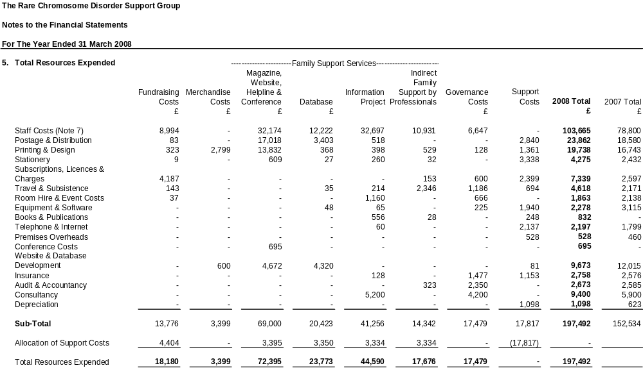

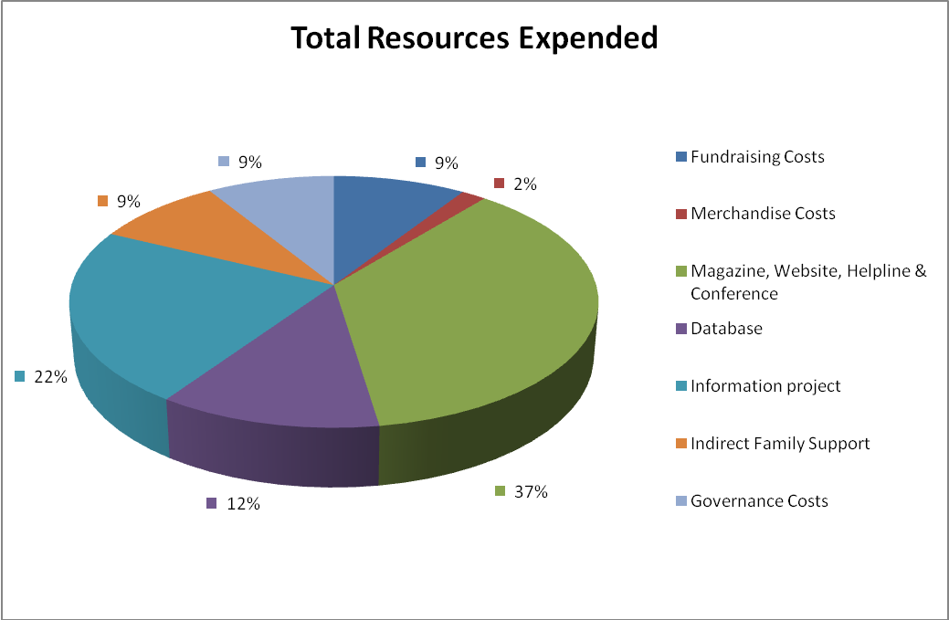

Back to contents

6. | Net Movement in Funds
 | This is stated after charging:
 |  |  |  |  |  |  |  |  |  |  | 2008 |  | 2007
 |  |  |  |  |  |  |  |  |  |  | £ |  | £
 | Depreciation |  |  |  |  |  |  |  |  |  | 1,098 |  | 623
 | Trustees' indemnity insurance |  |  |  |  |  |  |  |  |  | 1,477 |  | 1,575
 | Trustees' reimbursed expenses |  |  |  |  |  |  |  |  |  | Nil |  | Nil
 | Auditors' remuneration:
 | ▪ | Statutory Audit |  |  |  |  |  |  |  |  | 2,350 |  | 2,350
 | ▪ | Grant Audit |  |  |  |  |  |  |  |  | 323 |  | -
 | ▪ | Under-Accrual in Prior Year |  |  |  |  |  |  |  |  | - |  | 235
7. | Staff Costs and Numbers
 | Staff costs were as follows:
 |  |  |  |  |  |  |  |  |  |  | 2008 |  | 2007
 |  |  |  |  |  |  |  |  |  |  | £ |  | £
 | Salaries and Wages |  |  |  |  |  |  |  |  |  | 93,816 |  | 72,153
 | Social Security Costs |  |  |  |  |  |  |  |  |  | 8,515 |  | 6,386
 | Casual Staff |  |  |  |  |  |  |  |  |  | 1,334 |  | 261
 |  |  |  |  |  |  |  |  |  |  | 103,665 |  | 78,800
 | No employee earned more than £60,000 during the year.
 |  |  |  |  |  |  |  |  |  |  | 2008 |  | 2007
 |  |  |  |  |  |  |  |  |  |  | No. |  | No.
 | Average number of employees (full-time equivalent) |  |  |  |  |  |  |  |  |  | 3.97 |  | 3.24
8. | Taxation
 | The charity is exempt from corporation tax as all its income is charitable and is applied for charitable purposes.

Back to contents

9. | Tangible Fixed Assets
 |  |  |  |  |  |  |  |  |  |  |  |  | Total
 |  |  |  |  |  |  |  |  |  |  |  |  | £
 | Cost
 | At 1 April 2007 |  |  |  |  |  |  |  |  |  |  |  | 2,493
 | Additions in year |  |  |  |  |  |  |  |  |  |  |  | 1,901
 | At 31 March 2008 |  |  |  |  |  |  |  |  |  |  |  | 4,394
 | Depreciation
 | At 1 April 2007 |  |  |  |  |  |  |  |  |  |  |  | 1,299
 | Charge for the year |  |  |  |  |  |  |  |  |  |  |  | 1,098
 | At 31 March 2008 |  |  |  |  |  |  |  |  |  |  |  | 2,397
 | Net Book Value
 | At 31 March 2008 |  |  |  |  |  |  |  |  |  |  |  | 1,997
 | At 31 March 2007 |  |  |  |  |  |  |  |  |  |  |  | 1,194
10. | Investments
 |  |  |  |  |  |  |  |  |  |  | 2008 |  | 2007
 |  |  |  |  |  |  |  |  |  |  | £ |  | £
 | Artwork |  |  |  |  |  |  |  |  |  | 700 |  | 700
 | During 2005 Tracey Emin donated 2 pictures to the charity. One was sold in 2006/7. The trustees have no immediate plans to sell the remaining picture, consequently it has been reported as a fixed asset investment in the accounts. Two professional valuations have been obtained and the picture has been included in the accounts at the average of these valuations.
11. | Stock
 |  |  |  |  |  |  |  |  |  |  | 2008 |  | 2007
 |  |  |  |  |  |  |  |  |  |  | £ |  | £
 | Merchandise |  |  |  |  |  |  |  |  |  | 1,453 |  | 1,203
12. | Debtors
 |  |  |  |  |  |  |  |  |  |  | 2008 |  | 2007
 |  |  |  |  |  |  |  |  |  |  | £ |  | £
 | Prepayments |  |  |  |  |  |  |  |  |  | 6,280 |  | 6,022
 | Other Debtors |  |  |  |  |  |  |  |  |  | 413 |  | 6,709
 |  |  |  |  |  |  |  |  |  |  | 6,693 |  | 12,731

Back to contents

13. | Creditors : Amounts Due Within 1 Year
 |  |  |  |  |  |  |  |  |  |  |  | 2008 |  | 2007
 |  |  |  |  |  |  |  |  |  |  |  | £ |  | £
 | Accruals |  |  |  |  |  |  |  |  |  |  | 2,350 |  | 2,627
 | Other Taxation & Social Security |  |  |  |  |  |  |  |  |  |  | 2,156 |  | 1,883
 |  |  |  |  |  |  |  |  |  |  |  | 4,506 |  | 4,510
14. | Analysis of Net Assets Between Funds
 |  |  |  |  |  |  |  |  | Restricted Funds |  | Unrestricted Funds |  |  | Total Funds
 |  |  |  |  |  |  |  |  |  | £ |  | £ |  | £
 | Tangible Fixed Assets |  |  |  |  |  |  |  |  | - |  | 1,997 |  | 1,997
 | Investments |  |  |  |  |  |  |  |  | - |  | 700 |  | 700
 | Current Assets |  |  |  |  |  |  |  |  | 4,846 |  | 209,262 |  | 214,108
 | Current Liabilities |  |  |  |  |  |  |  |  | - |  | (4,506) |  | (4,506)
 | Net Assets at 31 March 2008 |  |  |  |  |  |  |  |  | 4,846 |  | 207,453 |  | 212,299

15. | Movements in Funds
 |  |  |  |  |  |  |  | At 1 April 2007 | Incoming Resources |  | Outgoing Resources |  | At 31 March 2007
 |  |  |  |  |  |  |  | £ |  | £ |  | £ |  | £
 | Restricted Funds
 | Charles Hayward Foundation |  |  |  |  |  |  | - |  | 10,000 |  | (10,000) |  | -
 | VICTA |  |  |  |  |  |  | - |  | 4,828 |  | (4,828) |  | -
 | SAFE Fund |  |  |  |  |  |  | 2,862 |  | - |  | - |  | 2,862
 | Eurogentest Fund |  |  |  |  |  |  | 4,077 |  | - |  | (2,093) |  | 1,984
 | Total Restricted Funds |  |  |  |  |  |  | 6,939 |  | 14,828 |  | (16,921) |  | 4,846
 | Unrestricted Funds
 | General Funds |  |  |  |  |  |  | 205,433 |  | 182,591 |  | (180,571) |  | 207,453
 | Total Unrestricted Funds |  |  |  |  |  |  | 205,433 |  | 182,591 |  | (180,571) |  | 207,453
 | Total Funds |  |  |  |  |  |  | 212,372 |  | 197,419 |  | (197,492) |  | 212,299
 | Purposes of Restricted Funds
 | Charles Hayward Foundation |  |  |  |  | To fund part of the Information Officer's salary
 | VICTA |  |  |  |  | To fund part of the Family Support Officer's salary
 | SAFE Fund |  |  |  |  | To fund all costs associated with the SAFE project
 | Eurogentest Fund |  |  |  |  | To fund all costs associated with the Eurogentest project

Back to contents

